**Task 4**

6 *×* 2 = 10 *marks*

**Name and Registration number: 22BCE3799 Apurba Koirala**



**The task files should have handwritten flow chart/Algorithm, and written Program, Snapshot of typed program and Snapshot of output.**

Implement the logic circuits using 8051 assembly code in KEIL and simulate the following equations

# F=(AB+C)’(C’D)’

Written code and flowchart:

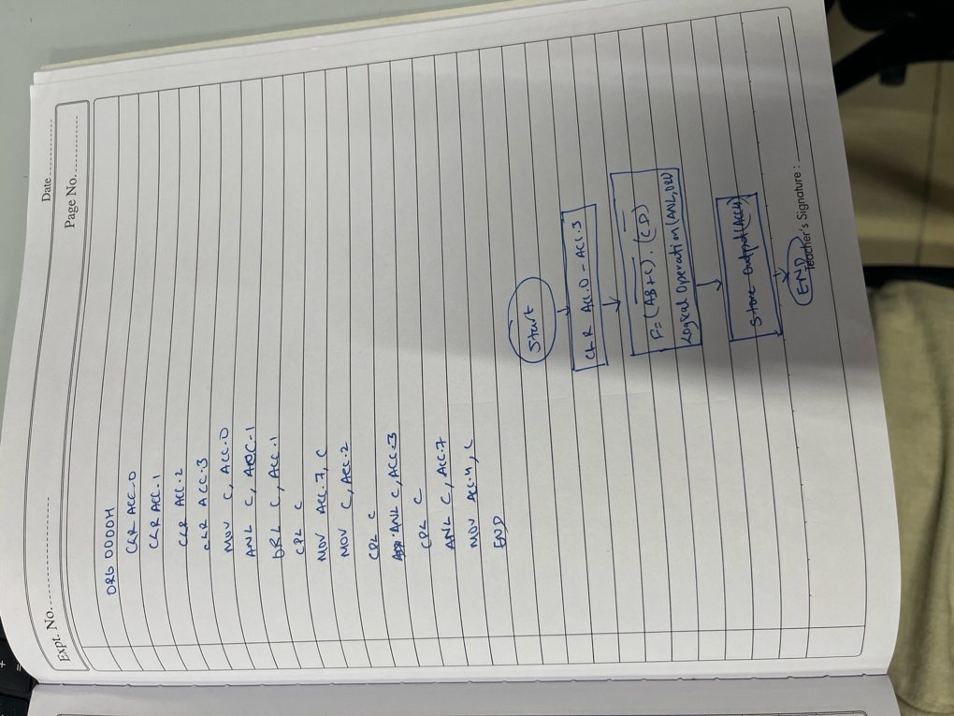

Code and Output:

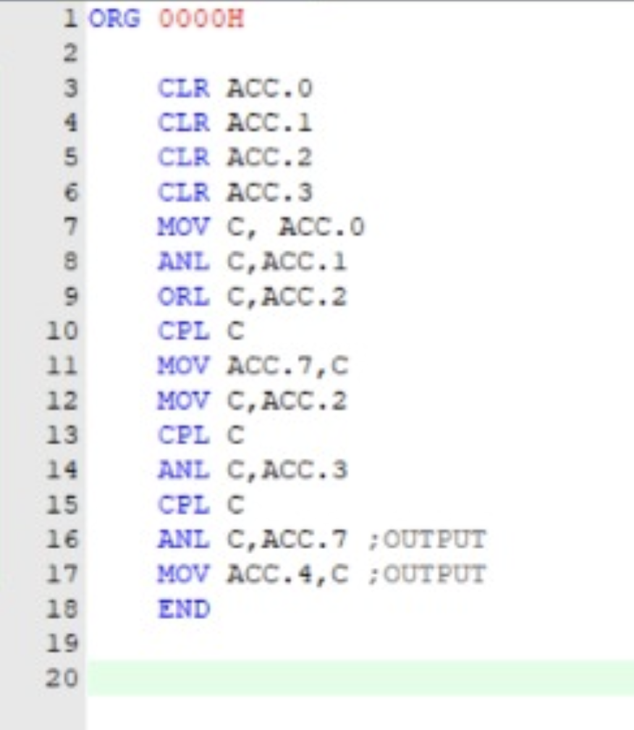

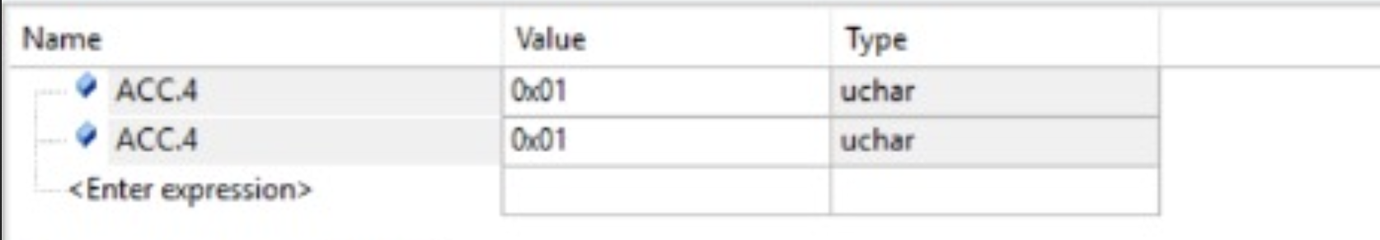

ORG 0000H

CLR ACC.0

CLR ACC.1

CLR ACC.2

CLR ACC.3

MOV C, ACC.0

ANL C,ACC.1

ORL C,ACC.2

CPL C

MOV ACC.7,C

MOV C,ACC.2

CPL C

ANL C,ACC.3

CPL C

ANL C,ACC.7 ;OUTPUT

MOV ACC.4,C ;OUTPUT

END

# C=AB’+BB’; D=AB

Written code and flowchart

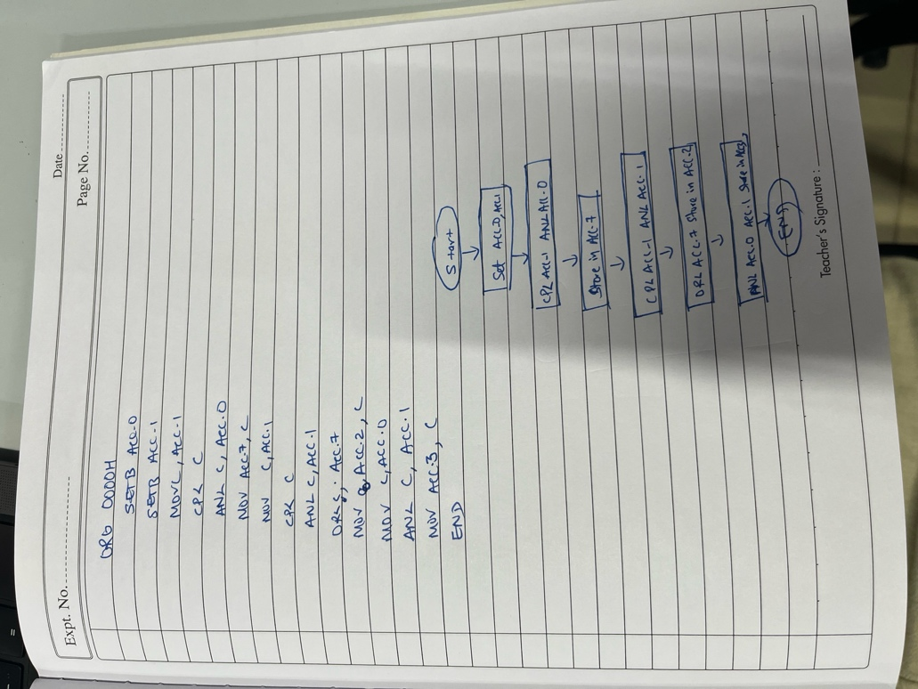

Code and Output:

ORG 0000H

SETB ACC.0

SETB ACC.1

MOV C, ACC.1

CPL C

ANL C, ACC.0

MOV ACC.7, C

MOV C, ACC.1

CPL C

ANL C, ACC.1

ORL C, ACC.7

MOV ACC.2, C

MOV C, ACC.0

ANL C, ACC.1

MOV ACC.3, C

END

